Copyright for test papers and marking guides remains with *West Australian Test Papers.*

Test papers may only be reproduced within the purchasing school according to the advertised Conditions of Sale.

Test papers should be withdrawn after use and stored securely in the school until Wednesday 11th October 2017.



**MATHEMATICS**

**METHODS**

**UNITS 3 & 4**

**Semester Two**

**2017**

**SOLUTIONS**

***Calculator−free Solutions***

1. (a) 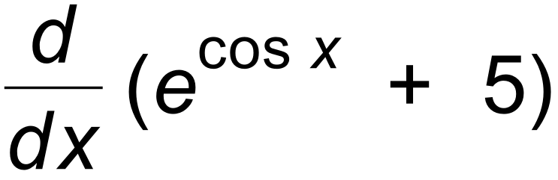

= – sin x e cos x ✓✓

(b) 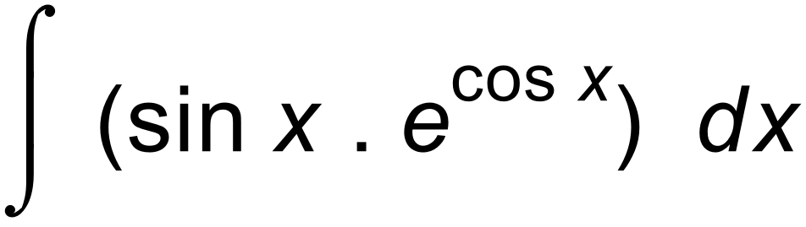

= 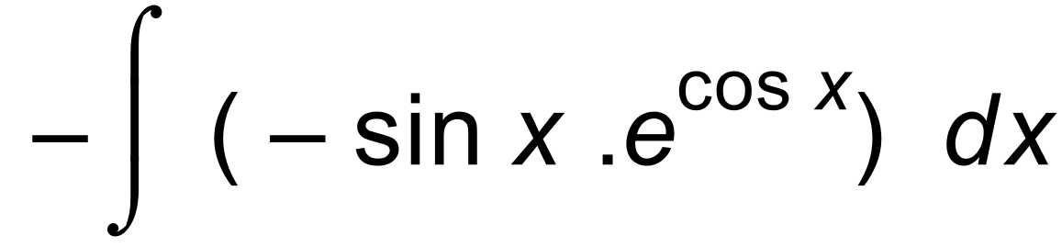

= – e cosx + c ✓✓ [4]

2. (a) f ´(x) = 2e2x –  ✓

For max/min, 2e2x –  = 0 ✓

 2xe2x – 1 = 0 ✓

x = 0.5 e –2x

(b) f ′′(x) = 4e2x + 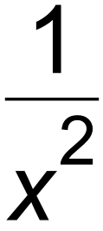

Since expression > 0 for all x values, ✓

then stationary point is a minimum. ✓ [5]

3. (a) A = 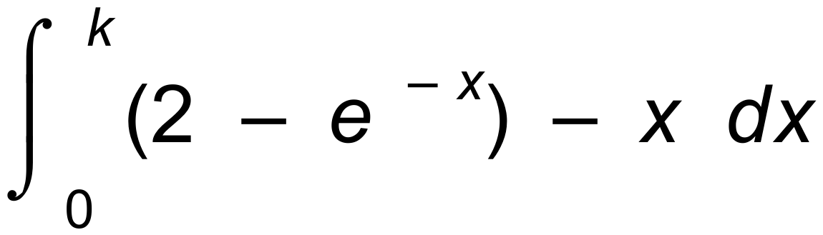 ✓✓

(b) A = 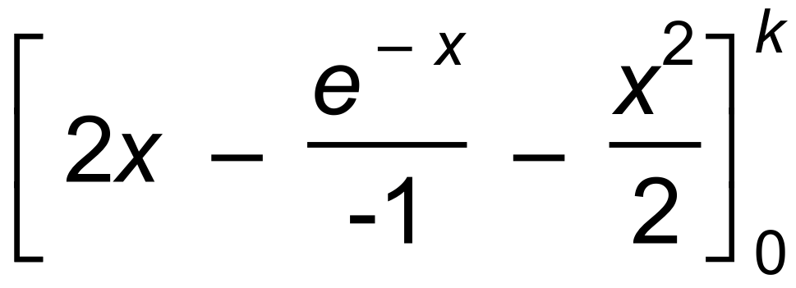 ✓

= (2k + e –k – 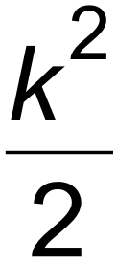 ) – 1 ✓✓ [5]

4. (a) 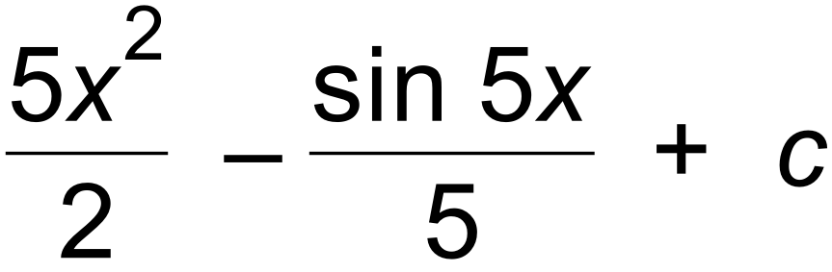 ✓✓

(b) 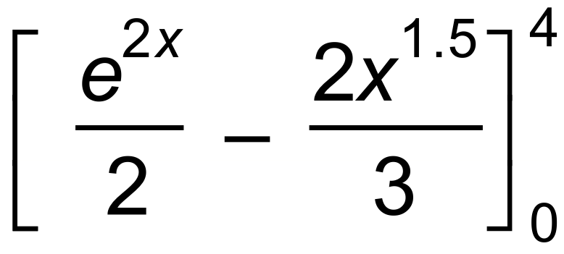 ✓

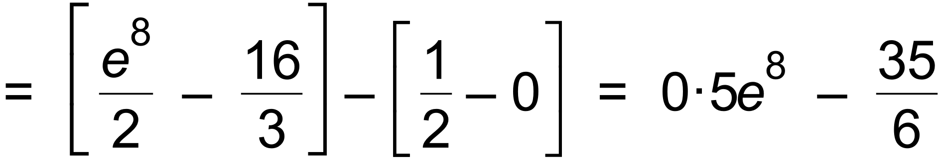 ✓✓

(c) 2 sin 2x ✓✓ [7]

5. (a) x = sin 2t + e –2t +c ✓

x(0) = 0+1 + c = 1  c = 0 ✓

x = sin 2t + e –2t ✓

(b) a = –4sin 2t + 4e –2t ✓✓

(c) Assume a = – k2x

Then –4 sin 2t + 4 e –2t = – k2(sin 2t + e –2t)

This leads to the result that k2 = 4 and k2 = –4.

Hence, relationship is false.

Or a = –4(sin 2t – 4e –2t) −4(sin 2t + 4e –2t) = −22x

✓✓ [7]

6. (a) log (  ) + log ( 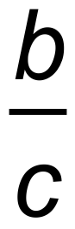 ) + log (  )

= log 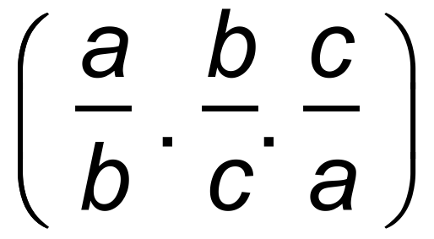 ✓

= log 1 = 0 ✓

(b) y = 1 – x

2x = 31 – x

x log 2 = (1 – x)log 3 ✓

x log 2 + x log 3 = log 3 ✓

x = 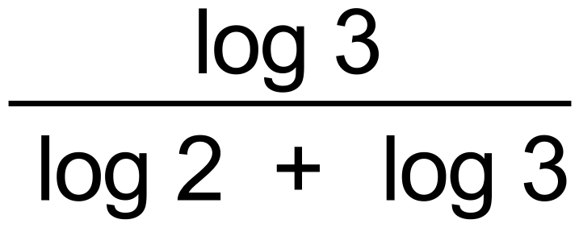 ✓

x = 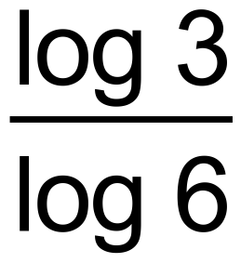 as required ✓

y = 1 –  ✓ [7]

7. (a) (i) 14 ✓

(ii) 14 + 6 – 6 = 14 ✓✓

(iii) 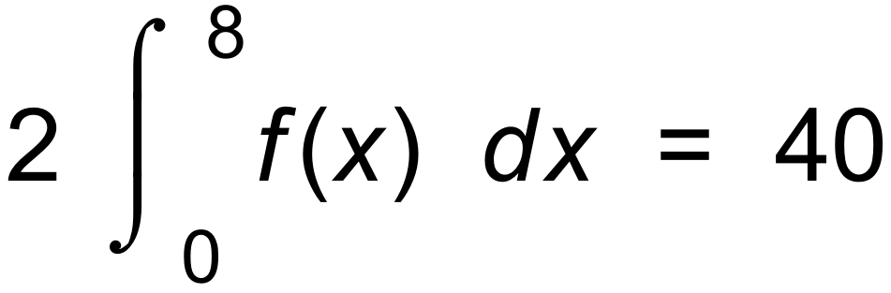 ✓✓

(b) 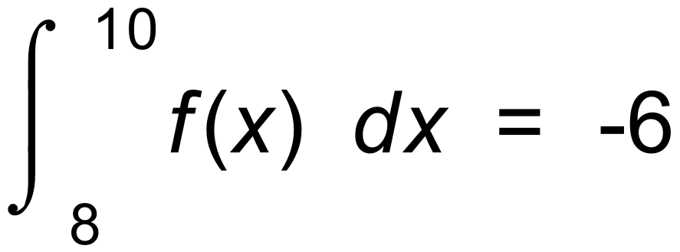 ✓

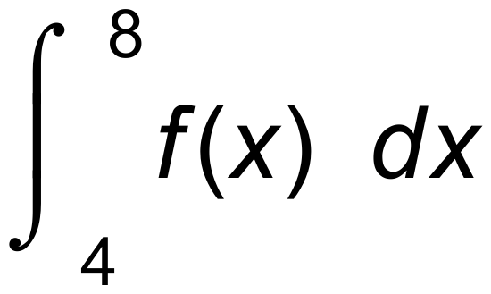 = 6 ✓

 a = 4, b = 8, c = 10 ✓ [8]

8. (a) A = Length x Width = 3xcos 2x ✓

(b) A = 3x cos 2x

A′ = 3x (–sin 2x)(2) + 3cos 2x = 0 for max / min ✓

6xsin 2x = 3cos 2x ✓

2x tan 2x = 1 as required. ✓

(c) A′′ = –12 sin 2x – 12xcos 2x ✓

= –12(sin 2x + xcos 2x) ✓

< 0 for maximum ✓

 sin 2x + x cos 2x > 0 as required [7]

***Calculator−assumed Solutions***

9. (a) Solve 0.9 = 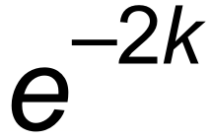

∴ *k* = 0.05268 = 0.0527 ( 3 s.f.) ✓✓

(b) Solve 0.5 = 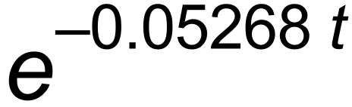

*t* = 13.153 ✓✓

Half life is 13.153 years.

(c) 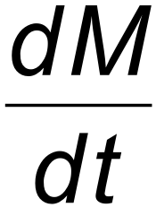 = *M*0 e –*k**t* . (–*k*) ✓

At *t* = 2,  = 20 . e – 0.0527 (2) . (–0.0527)

= – 0.9486 units of mass per year. ✓✓ [7]

10. (a) Only 2 results for each trial–single or married. ✓

(b) 0.6 ✓

(c) 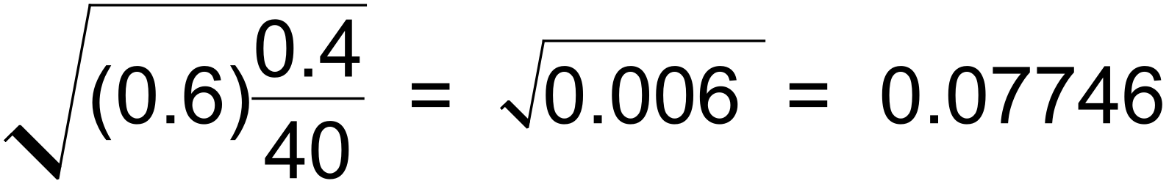 ✓✓

(d) We can be 95% confident that the true proportion is *p*

where 0.6 –(1.96)( 0.07746) < *p* < 0.6 + (1.96)( 0.07746)

ie 0.4482 < *p* < 0.7518 ✓✓

(e) *n* = 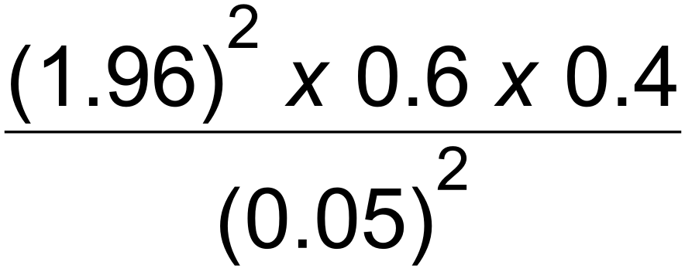 ✓

*n* = 368.8 ✓

Sample size needs to be 369. ✓ [9]

11. (a) From calculator, 0.142 ✓

(b) sin *x* has a minimum of –1. So, 2 + sin *x* has a minimum of 1

So log(2 + sin *x*)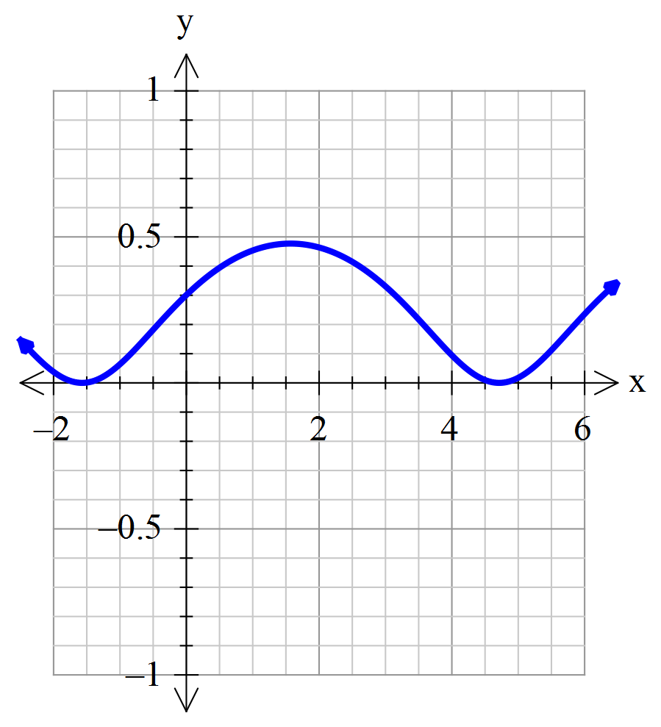 has a minimum of 0. ✓✓

(c)

✓✓✓

(d) By inspecting the graph, all of this curve is above the *x* axis. ✓

 since  ✓

Area = 0.5(0.142) = 0.071 ✓ [9]

12. (a) Minimum when *f* ′(*x*) = 0

∴ 2 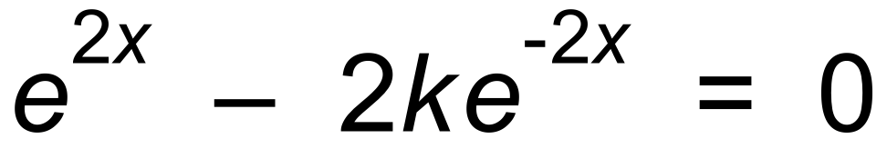 ✓

∴ 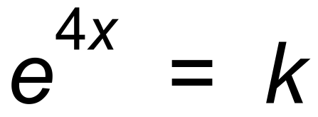

∴ *x* = 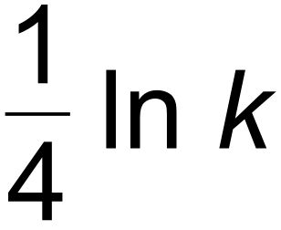 ✓

∴ Minimum value is 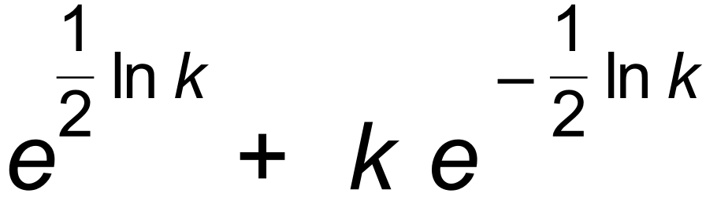

= 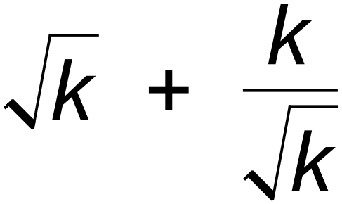 = 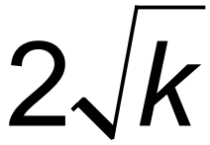 ✓

∴ Range is 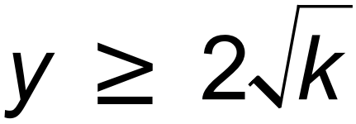 ✓

(b) 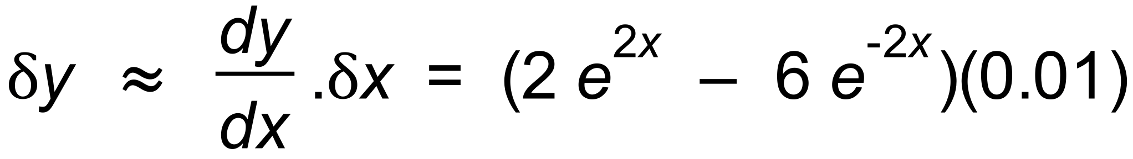 ✓✓

= 1.09 ( 2 decimal places) ✓

(c) *f*(2) = 54.653

*f*(2.01) = 55.755 ✓

Change is 1.10 ( 2 decimal places) ✓ [9]

13. (a) Not equally likely outcomes, so biased. ✓

(b)  ✓

(c) E(X) = 1.875 Var(X) = 1.05332 = 1.109 ✓✓

(d) P(Y = 4) = 5C4 (0.25)4(0.75) = 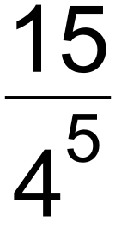 = 0.0146 ✓✓

(e) P(five 4s) = 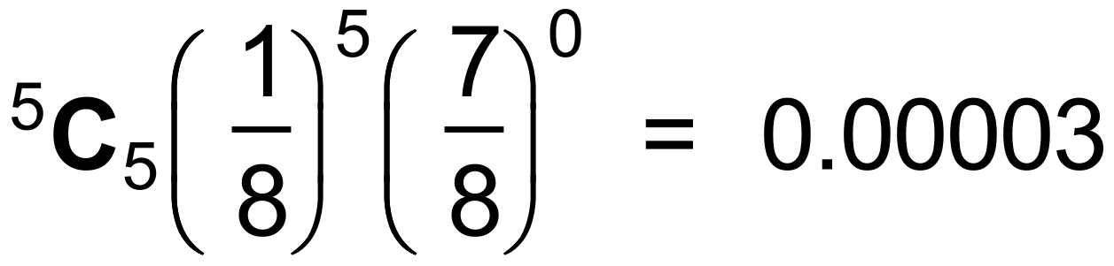 ✓ ✓

[8]

14. (a)

|  |  |  |  |  |  |
| --- | --- | --- | --- | --- | --- |
| *z* | 1.1 | 1.3 | 1.7 | 2.0 | 2.4 |
| *d* | 130 | 220 | 490 | 800 | 1400 |
| Log *z* | 0.0414 | 0.1139 | 0.2305 | 0.3010 | 0.3802 |
| Log *d* | 2.11 | 2.34 | 2.69 | 2.90 | 3.15 |

✓✓

(b)

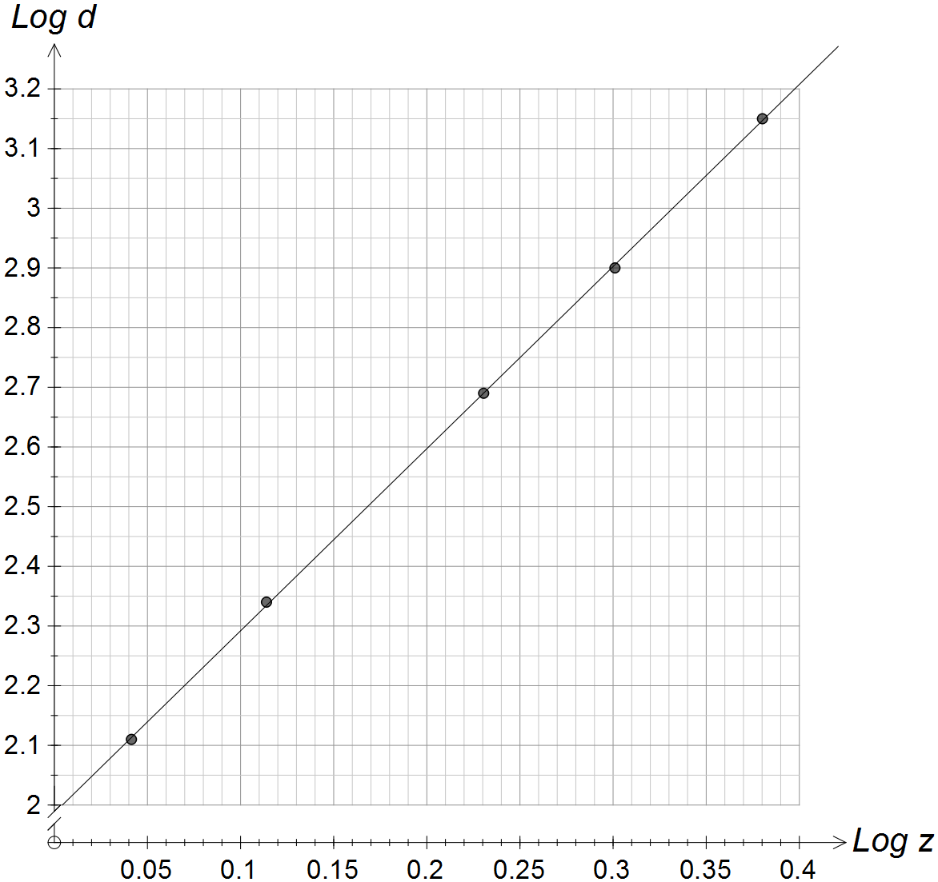

✓✓✓

(c) log *d* = 2 + 3log *z* ✓✓

(d) *d* = 100.z3 ✓✓[9]

15. (a) A = 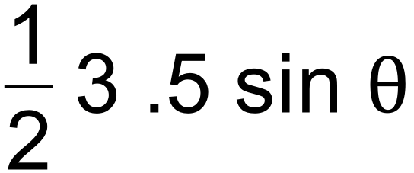 = 7.5 sin 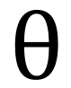 ✓

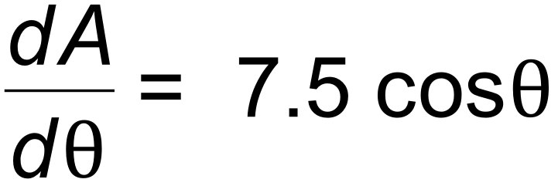 ✓

(b) 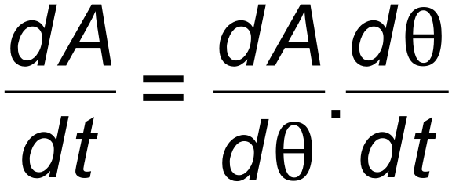

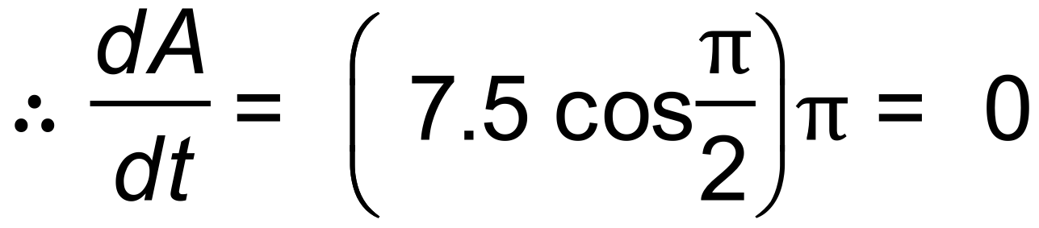 ✓✓

(c) Area has reached a maximum value. ✓ [5]

16. (a)  ✓

(b) 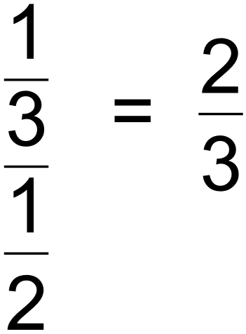 ✓✓

(c) 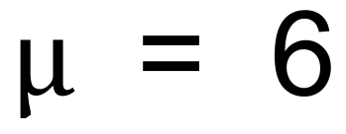 and Var (X) = 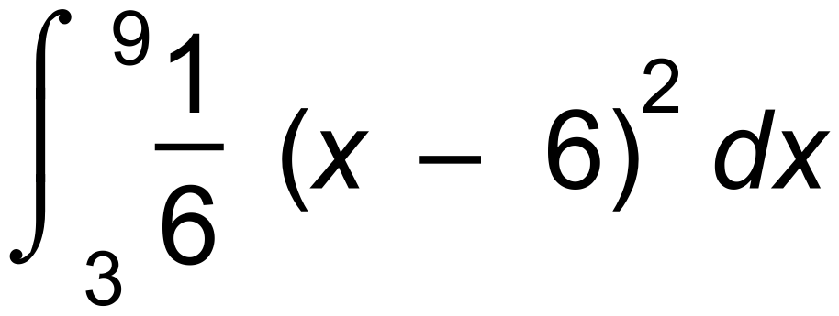 = 3

s(x) = 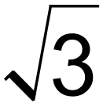 or 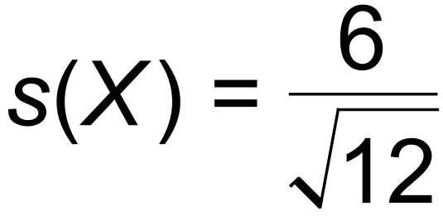 by formula ✓✓

(d)  ✓

s(*y*) = 2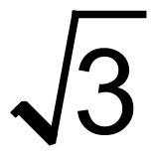 ✓ [7]

17. (a) P(390 < X < 410) = 0.15852 ✓✓

(b) P(X < 400 + *k*) = 0.96 ✓

∴ 400 + *k* = 487.534

∴ *k* = 87.534 ✓

(c) *m* = 810 *s* = 100 ✓✓ [6]

18. (a) 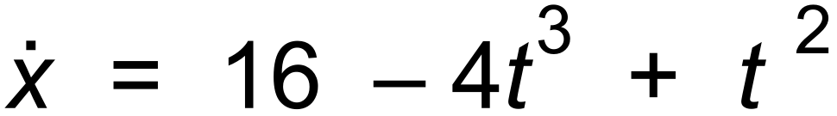

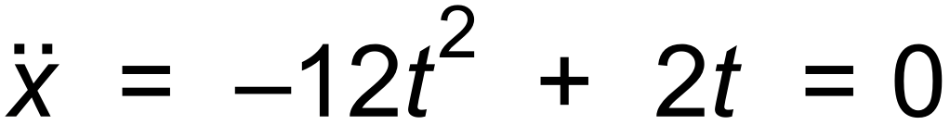 ✓

∴ *t* = 0 or  ✓

(b) 16 – 4*t*3 + *t*2 = 0 ✓

*t* = 1.68 ✓

(c) –12*t*2 + 2*t* is a maximum when –24*t* + 2 = 0

ie when *t* = 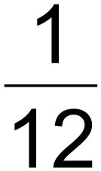 ✓

*x* = 5.33 ✓

(d) 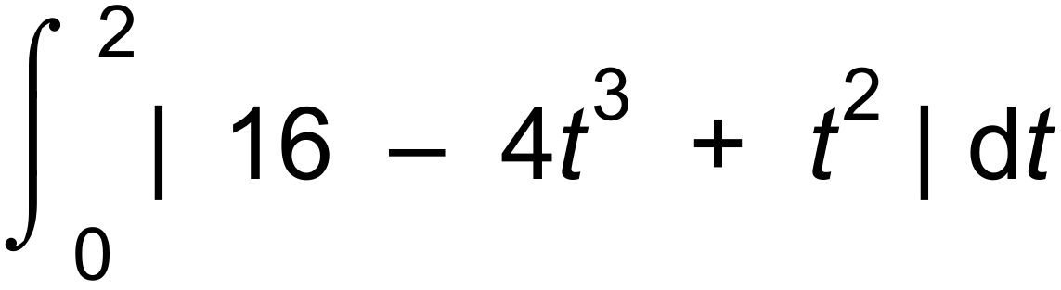 = 22.323 m ✓✓ [8]

19. (a) Normal curve ✓

(b) mean = 21 ✓

standard deviation = 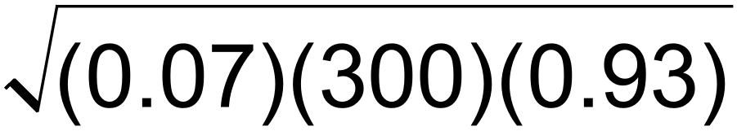 = 4.4193 ✓

(c)  = 0.07 ✓

standard deviation = 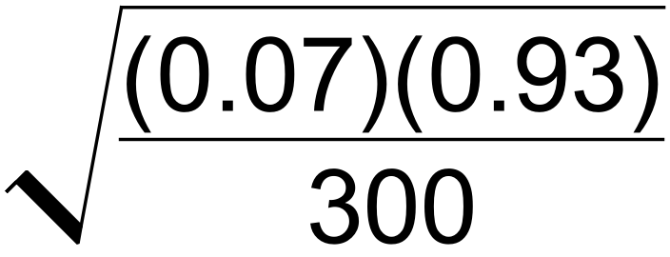 = 0.0147 ✓✓

(d) This is a proportion of 0.15

*Z* = 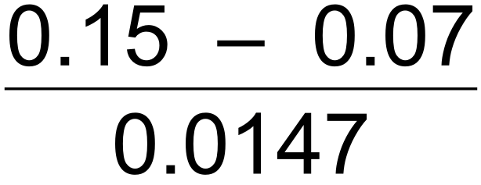 = 5.44

5.44 standard deviations above the mean is very unlikely.

The testing method may need reviewing. ✓✓ [8]

20. (a) Binomial ( 100, 0.02) ✓

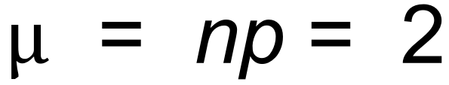 ✓

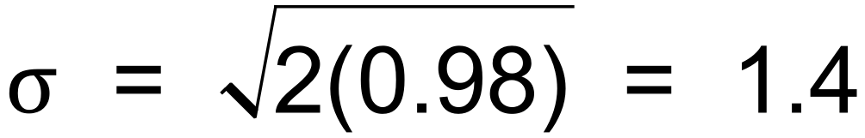 ✓

(b)  = 0.0508 ✓✓

(c) *n* = 2000, *p* = 0.02, X = 40

90% interval is 0.0149 to 0.0251 from CAS ✓✓

(d) P(X = 2) = 3C2 (0.9)2(0.1) = 0.243 or from CAS ✓✓

(e) 0.0149 x 2000  30

0.0251 x 2000  50 ✓✓

(f) Interval is from 30 to 50.

Sample 2 is outside. ( 57 > 50 )

Sample 3 is outside. ( 28 < 30 ) ✓✓ [13]